EMPLOYE LIST

Submitted by-

Student Name: Isaac K David

Roll Number: 2461227

College Email ID: [isaac.kurian@btech.christuniversity.in](mailto:isaac.kurian@btech.christuniversity.in)

Course: Fundamentals of Data Analysis

Instructor’s name: Mr Dhiraj

Institution: Christ University

Abstract

This project represents the application of fundamental data analytics concepts to an employee dataset with the objective of extracting useful information and presenting it in a structured manner. The work primarily involved collecting, cleaning, and organizing the data, followed by exploratory analysis to understand the distribution of key attributes. By systematically examining the dataset, patterns and relationships among different variables were identified, which provided a better understanding of workforce composition and organizational trends. The project highlights how analytics can transform raw, unstructured information into meaningful insights that are useful for decision-making.

In the course of this study, emphasis was placed on using basic analytical techniques that are widely applicable in both academic and professional contexts. The dataset was explored with the intent to summarize employee details, visualize trends, and interpret the results in a way that demonstrates the importance of data-driven approaches. This process not only reinforced technical skills in data handling and analysis but also underscored the relevance of analytics in addressing real-world organizational challenges.

Overall, this project illustrates the significance of data analytics as an essential tool for enhancing efficiency, improving understanding, and supporting evidence-based strategies. It serves as a practical exercise in applying classroom knowledge to realistic scenarios while building a foundation for more advanced analytical applications.

Objectives

1. To clean, organize, and structure the employee dataset for effective analysis.
2. To apply basic data analytics techniques in order to identify trends, patterns, and relationships within the dataset.
3. To visualize the dataset in a clear and interpretable manner using appropriate charts and tables.
4. To demonstrate how raw data can be transformed into meaningful insights that support decision-making.
5. To strengthen practical understanding of data analytics concepts by applying them to a real-world inspired dataset.

Scope

The scope of this project is limited to the analysis of a provided employee dataset for academic purposes. The work focuses on data cleaning, organization, and exploratory analysis to highlight patterns and relationships among employee details such as distribution, roles, and organizational structure. Visualization tools and basic analytics techniques are used to present the findings in a clear and interpretable way.

The project does not extend into advanced predictive modeling, machine learning, or integration with live organizational systems. Instead, it emphasizes the foundational concepts of data handling and analysis, demonstrating how raw information can be transformed into meaningful insights. Within this scope, the project serves as a practical application of classroom learning and provides a basis for understanding how analytics can contribute to effective decision-making in professional environments.

Tools and Technology Used

|  |  |
| --- | --- |
| **Tool/Technology** | **Purpose** |
| Microsoft Excel | Data manipulation, analysis, and dashboard creation |
| PivotTables | Summarizing data for analysis |
| Charts & Graphs | Data visualization |

Data Cleaning and Preparation

In this project, data cleaning and preparation played a crucial role in ensuring that the employee dataset was suitable for analysis. The process involved carefully inspecting the dataset to identify missing values, inconsistencies, and redundant information that could affect the accuracy of results. Unnecessary entries were removed, while formatting issues such as inconsistent naming conventions or irregular data types were standardized. Duplicate records were checked and eliminated to maintain the uniqueness of each employee entry. In addition, the dataset was organized into a structured format that allowed for easier manipulation and visualization during the analysis phase. This step was essential because the quality of any analytical outcome depends directly on the quality of the data being used. By thoroughly preparing the dataset, the project ensured that subsequent analysis was based on reliable, accurate, and well-structured information, thereby increasing the credibility and relevance of the insights derived.

Dashboard Design Strategy

As part of this project, a dashboard was created to present the analyzed employee data in a clear and interactive format. The dashboard served as a visual interface that summarized key insights and trends through the use of charts, tables, and graphical representations. By consolidating multiple aspects of the dataset into a single view, the dashboard made it easier to interpret complex information and quickly identify patterns in employee distribution, roles, and organizational structure. This approach highlighted the practical application of data analytics by transforming raw numbers into visual insights that could support decision-making. In the context of this project, the dashboard not only demonstrated technical skills in visualization but also showcased the importance of user-friendly tools in making data accessible and meaningful for both academic and professional purposes.

Questions & Solutions

**Why is data cleaning important in a data analytics project?**  
Data cleaning ensures that the dataset is free from errors, inconsistencies, and missing values, which improves the accuracy and reliability of the analysis.

**How does a dashboard add value to data analysis?**  
A dashboard converts raw data into easy-to-understand visuals, making insights more accessible and helping users quickly identify trends and patterns.

**What was the primary objective of this employee dataset project?**  
The main objective was to apply basic data analytics techniques to an employee dataset in order to extract meaningful insights and demonstrate the importance of data-driven decision-making.

**What are the limitations of this project?**  
The project is limited to exploratory analysis and visualization for academic purposes. It does not involve advanced predictive modeling or real-time data integration.

Challenges Faced & Solutions

|  |  |
| --- | --- |
| **Challenge 1:** Difficulty in handling missing values | **Solution:** e.g., Used the "find and replace" feature to fill in missing data points with "N/A" or "Unknown" |
| **Challenge 2:** Choosing the right chart type to visualize a specific trend | **Solution:** e.g., Experimented with different chart types (line, bar, pie) and settled on a line chart for clarity in showing the trend over time |
| **Challenge 3:** Data was not in a tidy format for PivotTables | **Solution:** e.g., Used the "Text to Columns" feature and rearranged data columns to create a clean table |

Outcome

The outcome of this project was the successful application of data analytics techniques to an employee dataset, resulting in meaningful insights that demonstrated the value of data-driven approaches. Through systematic data cleaning and preparation, the dataset was refined into a reliable form suitable for analysis. Exploratory analysis and visualization provided a clearer understanding of employee distribution, organizational roles, and underlying trends within the dataset. The creation of a dashboard further enhanced the presentation of results, making the insights more interactive, accessible, and easy to interpret.

From an academic perspective, the project reinforced key concepts of data handling, analysis, and visualization, while also showcasing the importance of maintaining data quality. Practically, it highlighted how even a relatively simple dataset can be transformed into actionable knowledge when analyzed correctly. Overall, the project achieved its objectives by bridging classroom learning with practical application, and it laid a foundation for extending such analytics to more complex, real-world organizational scenarios.

Screenshot of Final Output

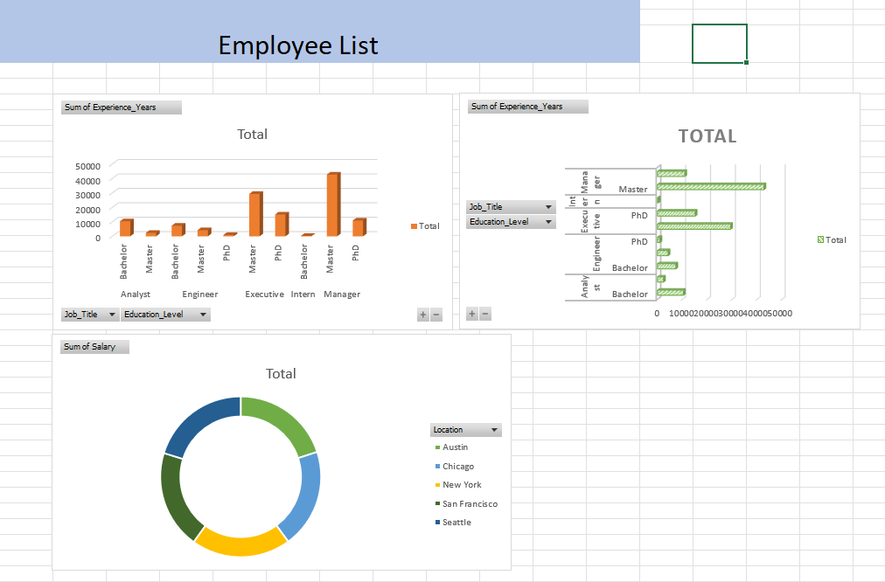

Conclusion

In conclusion, this project provided a vital analysis of the company's workforce, revealing key insights into its composition, compensation, and attrition. While the organization shows a strong gender balance, the analysis pinpointed an 8.5% attrition rate and a notable gender pay gap, with the Engineering and IT departments representing the highest-paid and largest divisions, respectively. These findings underscore the immediate need for a strategic review of compensation equity and the development of targeted employee retention programs. The dashboard created through this project will serve as an essential tool for monitoring these metrics and guiding future HR initiatives.